Year 11 Mathematics Methods

Investigation 1 2023

**Part A: Take Home Section**

***Instructions:*** *This investigation is made up of two sections: Part A and Part B.*

*Part A is the practice section, which is to be completed at home. All answers must be done neatly in the spaces provided. Written work must be completed in pen. Pencils must be used for diagrams and graphs.*

*Part B is the in-class section which will be a different, but related, problem that will be completed under test conditions on the day Part A is due.*

Time Allocation: one week Total Marks: 35 marks

**Investigating Graphs – Part A**

In previous work you learnt that the graph of has the same shape as that of but has been translated horizontally *b* units and translated vertically *c* units. The effect of the dilation factor, *a*,is to stretch or compress the curve depending on the value of *a.* Furthermore, if *a* was negative, the graph was inverted.

The aim of this investigation is to investigate translations and dilations in other functions.

### [2 marks]

On the axes below, accurately graph the following function: .

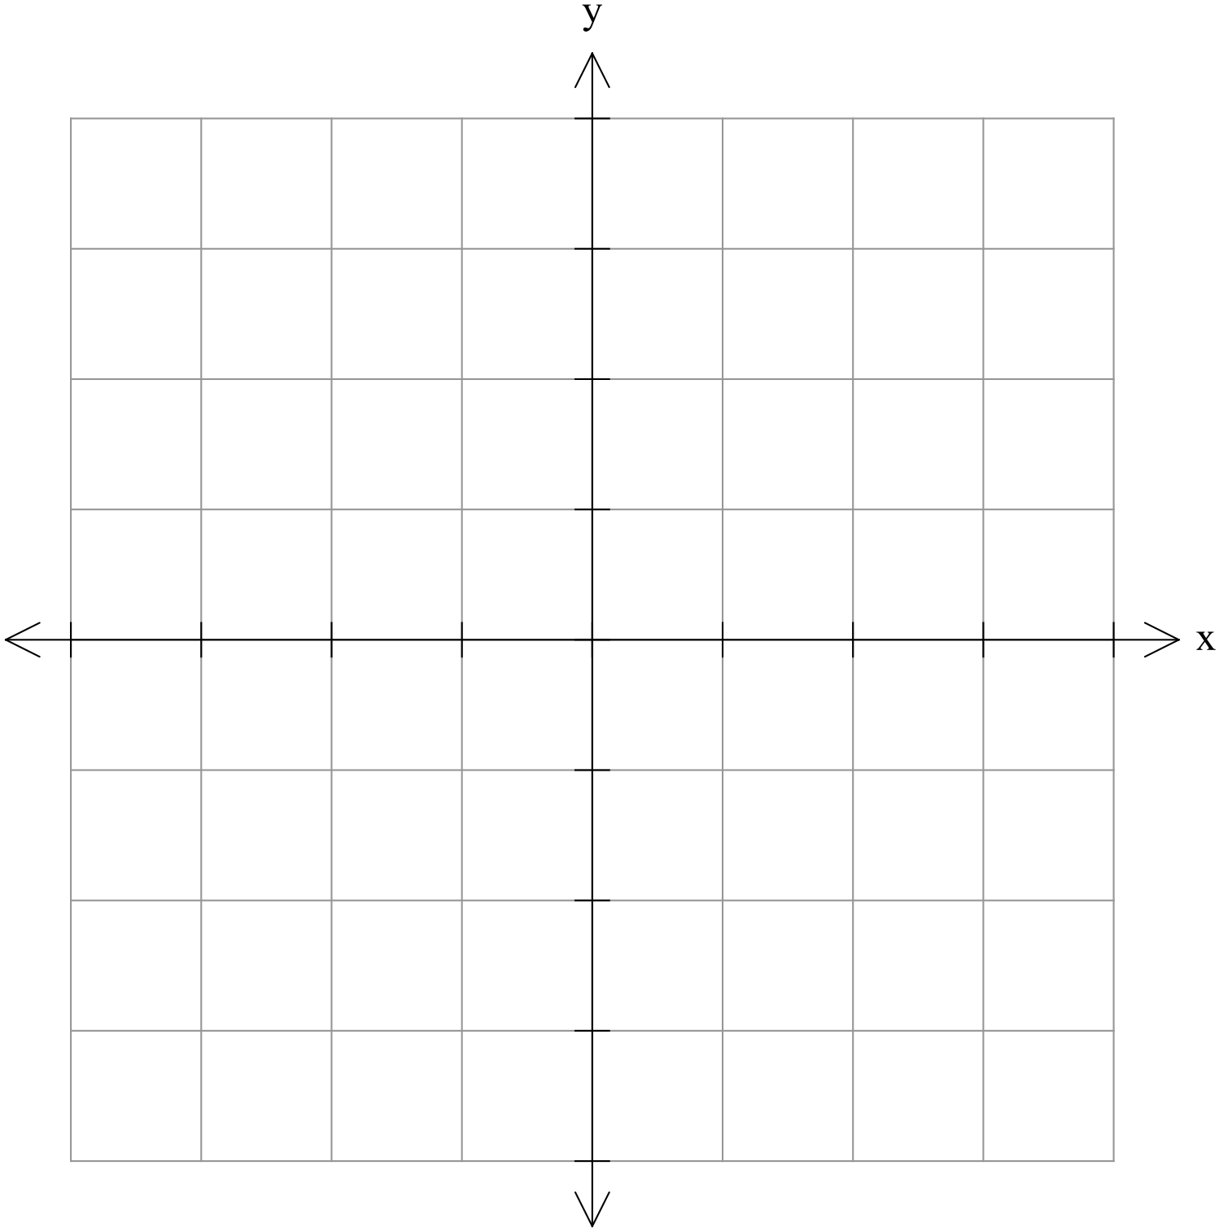

### [5 marks]

On the following axes, labelling everything clearly, graph the following functions:

and



### [4 marks]

On the following axes, labelling everything clearly, graph the following functions:

and

### [3 marks]

Comment on the effects that changes in *a* have on the graphs of .

### [5 marks]

On the following axes, labelling everything clearly, graph the following functions: 

and



### [5 marks]

On the following axes, labelling everything clearly, graph the following functions:

and

### [4 marks]

Comment on the effects that changes in *b* and *c* have on the graphs of .

### [3 marks]

On the following axes, labelling everything clearly, graph the following function:

### [4 marks]

(a) If the graph of has a *y-*intercept of 7, determine the value of *e*.

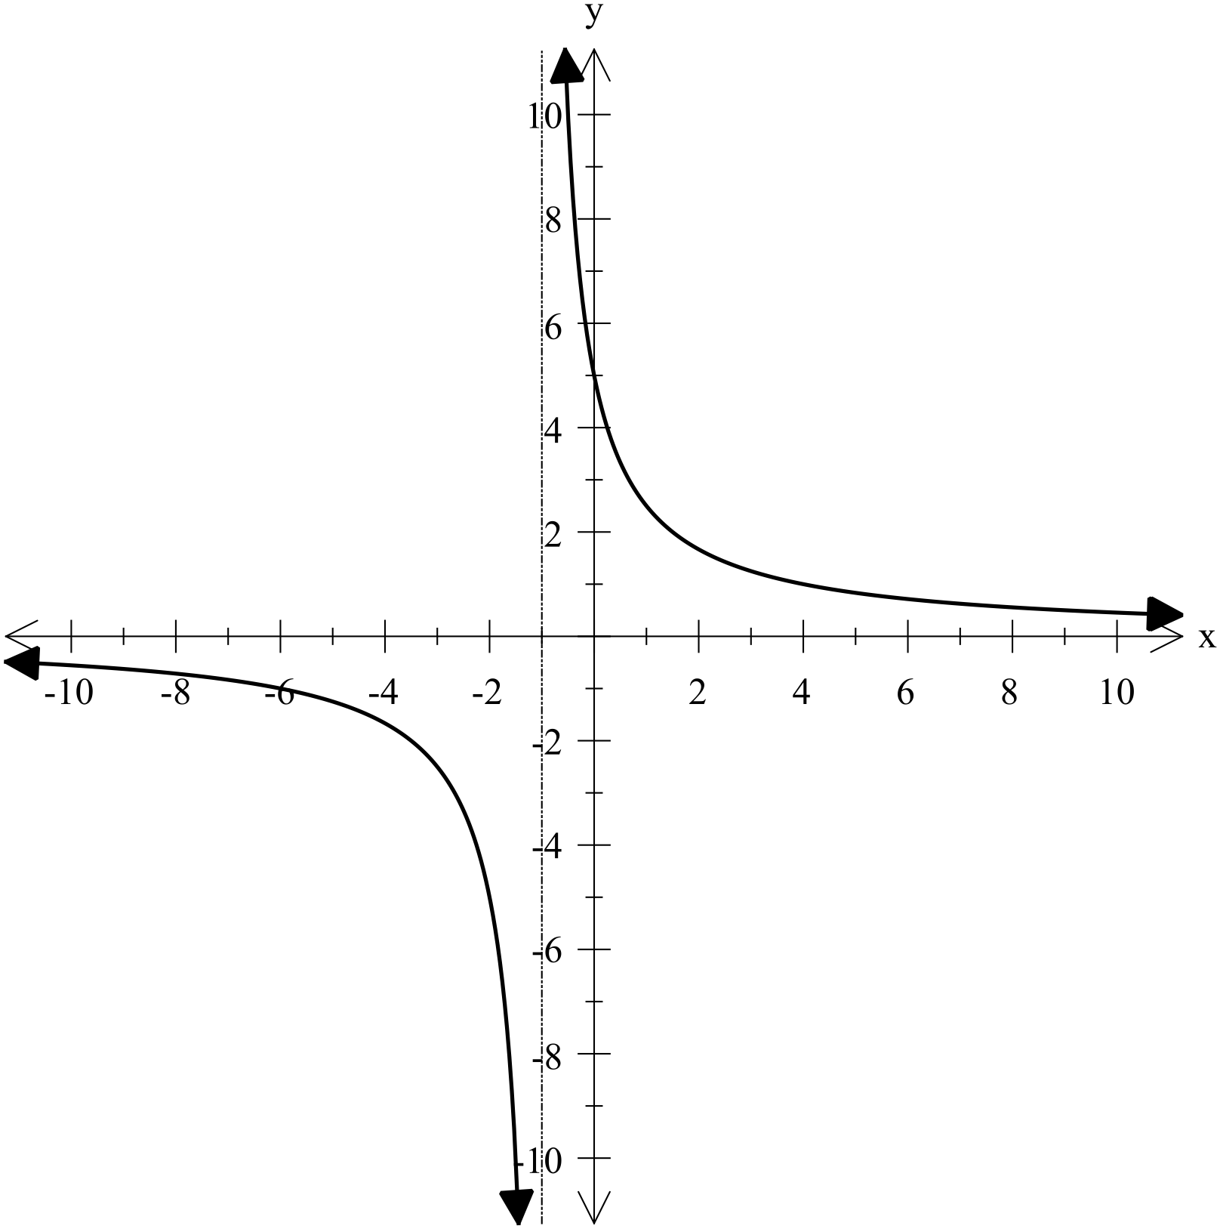

(b) The graph shown has an equation given as 

Determine the values of *r* and *s*.

**Investigating Graphs – Part A**

### [2 marks]

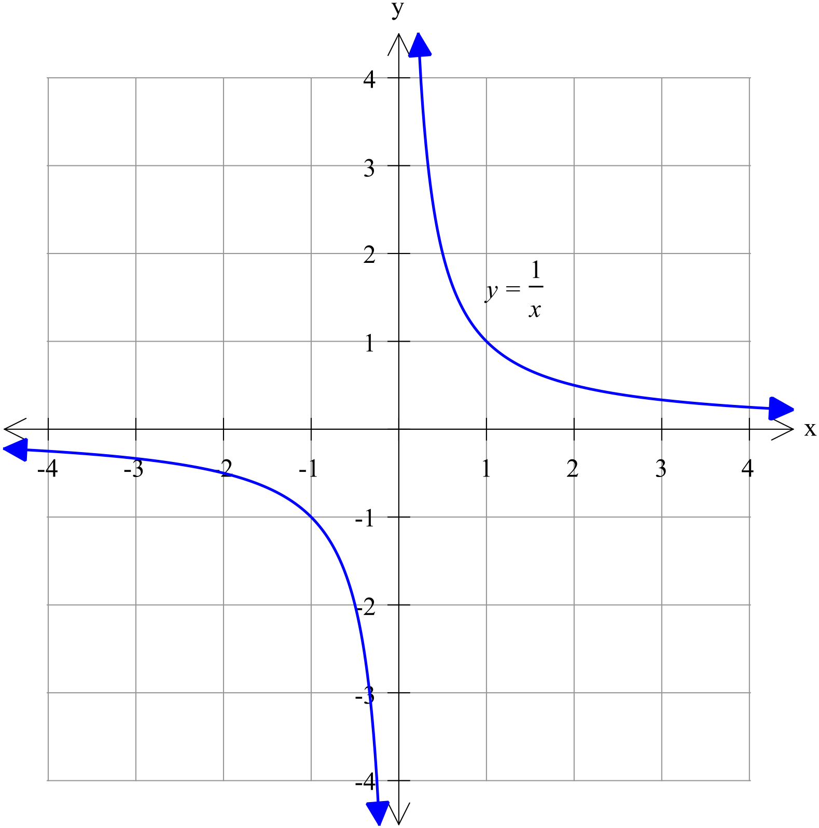

### [5 marks]

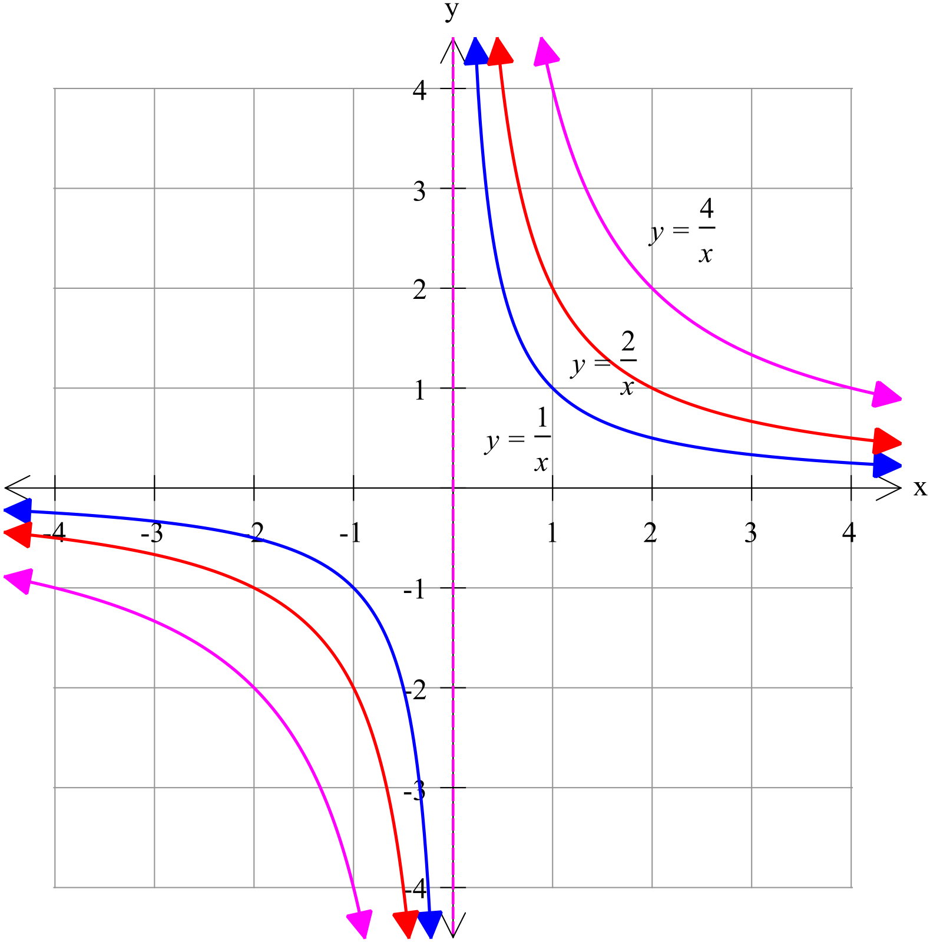

### [4 marks]

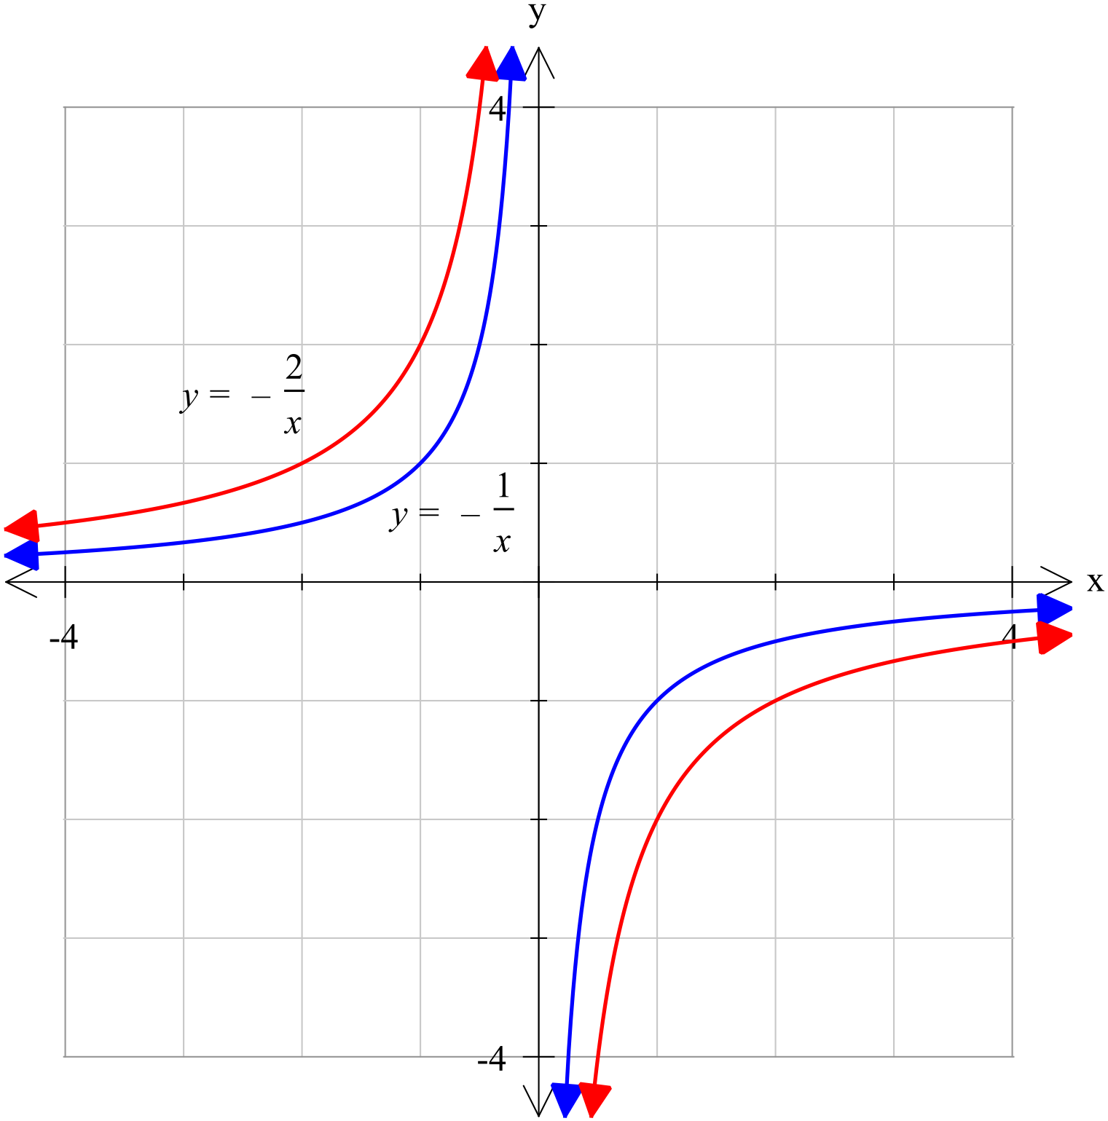

### [3 marks]

*a* is a dilation factor which stretches or compresses the graph of depending on the value of *a.* This affects the gradient of the curve and thus the distance the curve is from the axes. The larger the value of ⏐*a*⏐, the further it is from each axis.

Furthermore, if *a* is negative, the graph is inverted. That is the curves are in the second and fourth quadrants, rather than in the first and third.

### [5 marks]

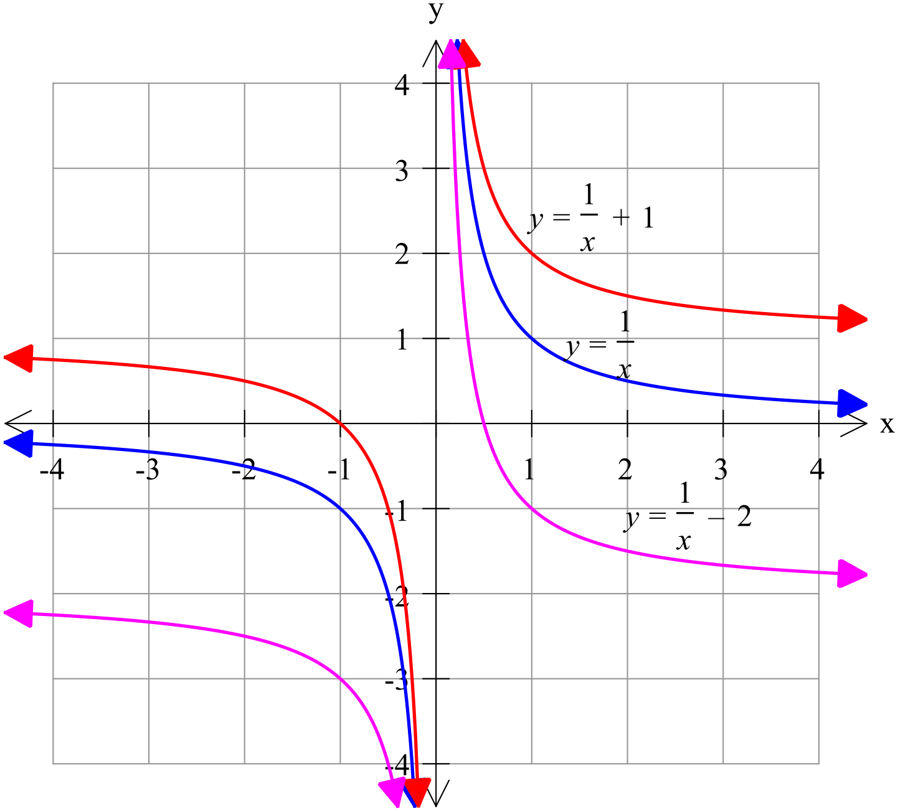

### [5 marks]

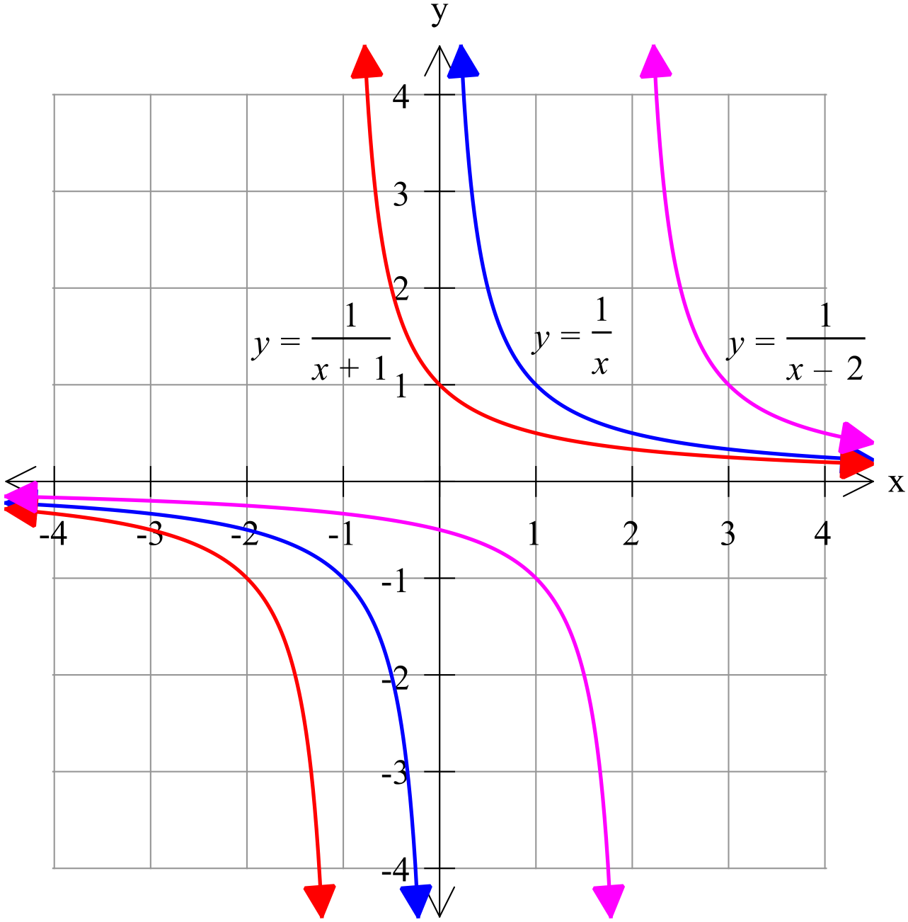

### [4 marks]

is congruent to but has been moved *b* units right and *c* units up.

That is *b* is the distance of the horizontal translation and *c* the vertical translation.

### [3 marks]

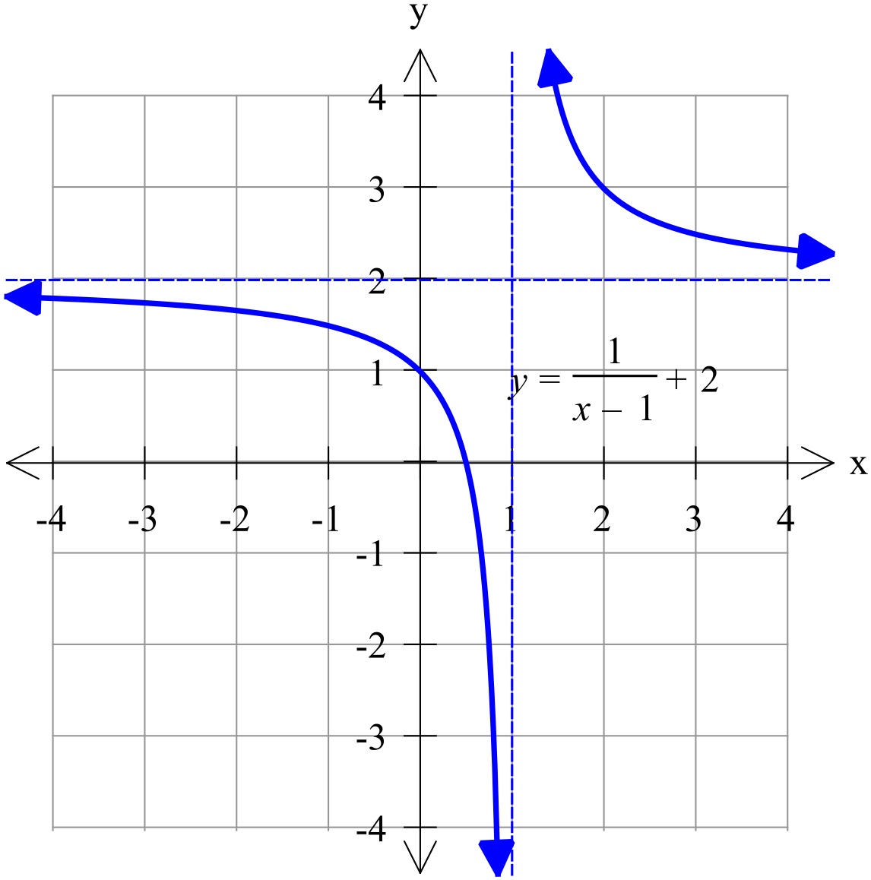

### [4 marks]

(a)

(b)

and

Total: 35 marks

Year 11 Mathematics Methods

Investigation 1 2023

**Part B: In Class Validation**

***Instructions:*** *Part B is the in-class validation to be completed under test conditions.*

*The practice section must be handed in prior to the start of the test. Calculators are permitted*

Time Allocation: 35 minutes Total Marks: 33 marks

**Investigating Graphs – Part B**

### [6 marks]

The graph of is given below.

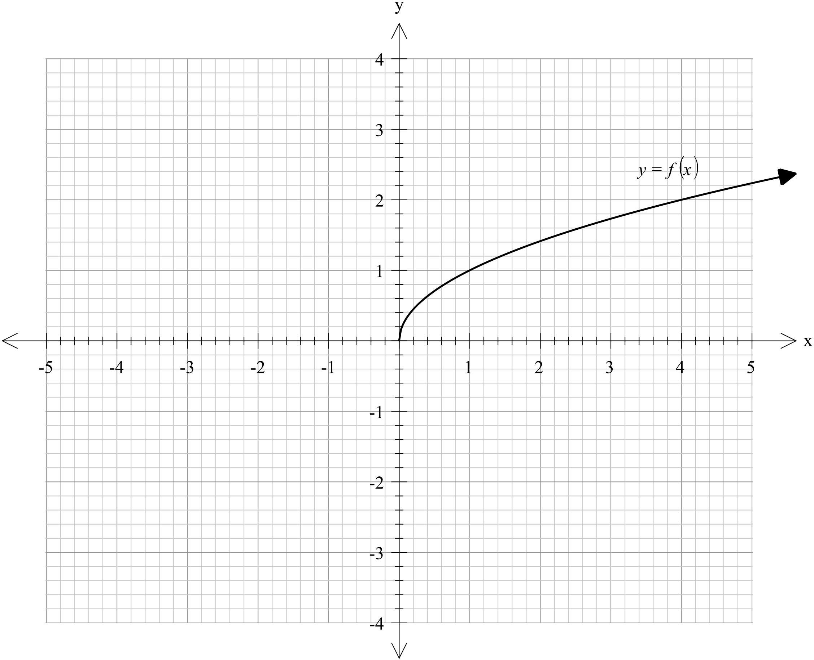

On the same grid above, sketch the graph of each of the following, labelling each clearly.

(a)

(b)

(c)

### [12 marks]

The following is the graph of the function .

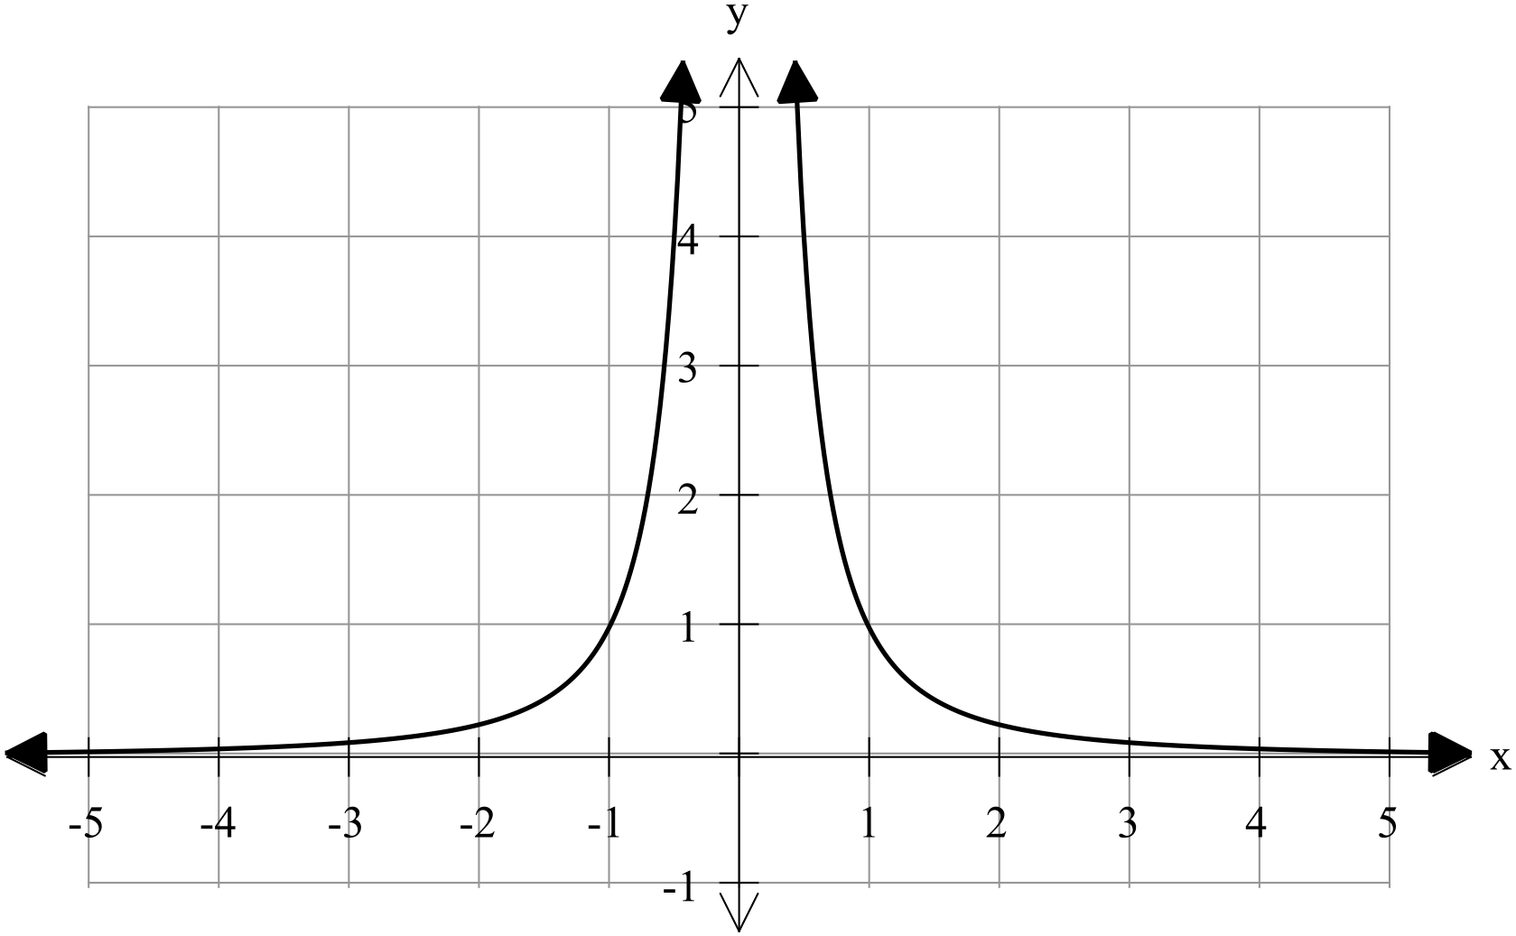

Use this graph to sketch the graph of each of the following functions.

(a) (b)

 

(c) (d)

 

### [2 marks]

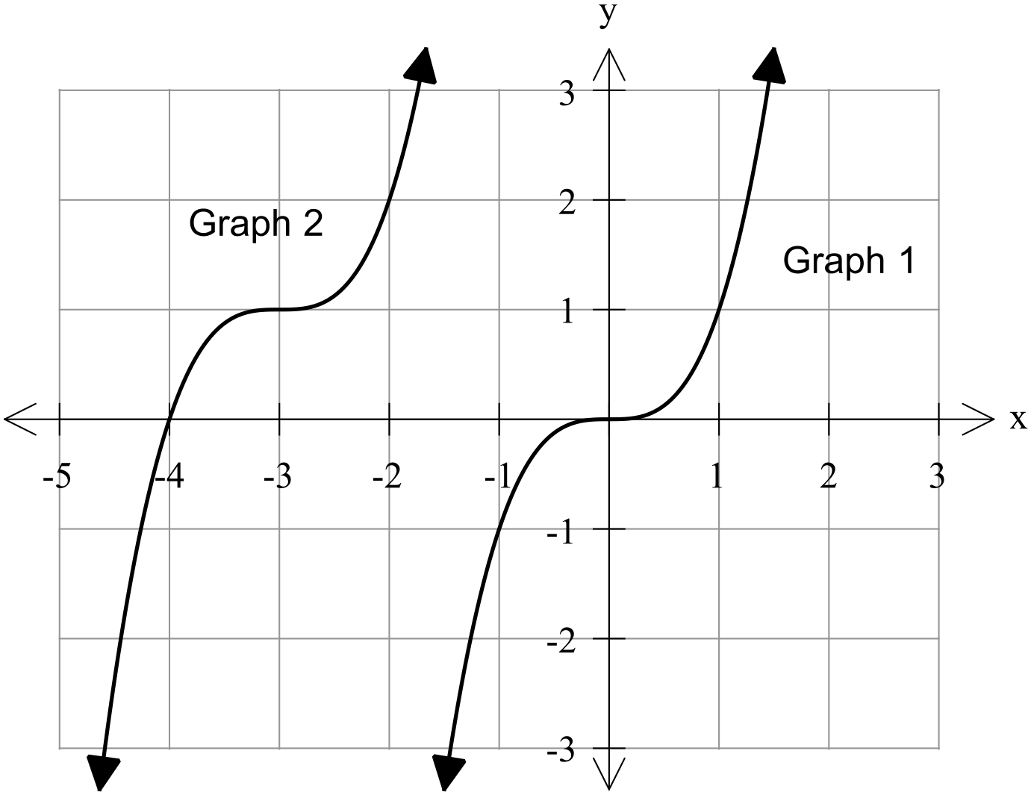

Given that Graph 1 is the graph of , write the function of Graph 2 in terms of .

### [2 marks]

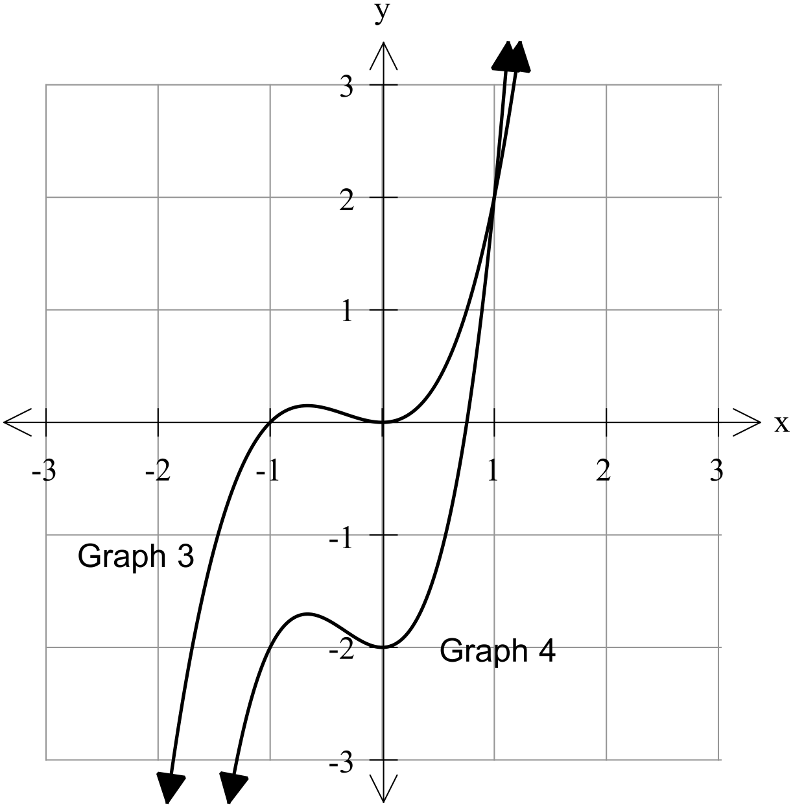

Given that Graph 3 is the graph of , write the function of Graph 4 in terms of .

### [4 marks]

On the following axes, labelling everything clearly, graph the following functions:

and

### [3 marks]

Comment on the differences between and .

7. [4 marks]

The graph of has a y intercept of (0, 6), a horizontal asymptote at and when . Determine the values of *a*, *b* and *c*.

**Investigating Graphs – Part B**

### [6 marks]

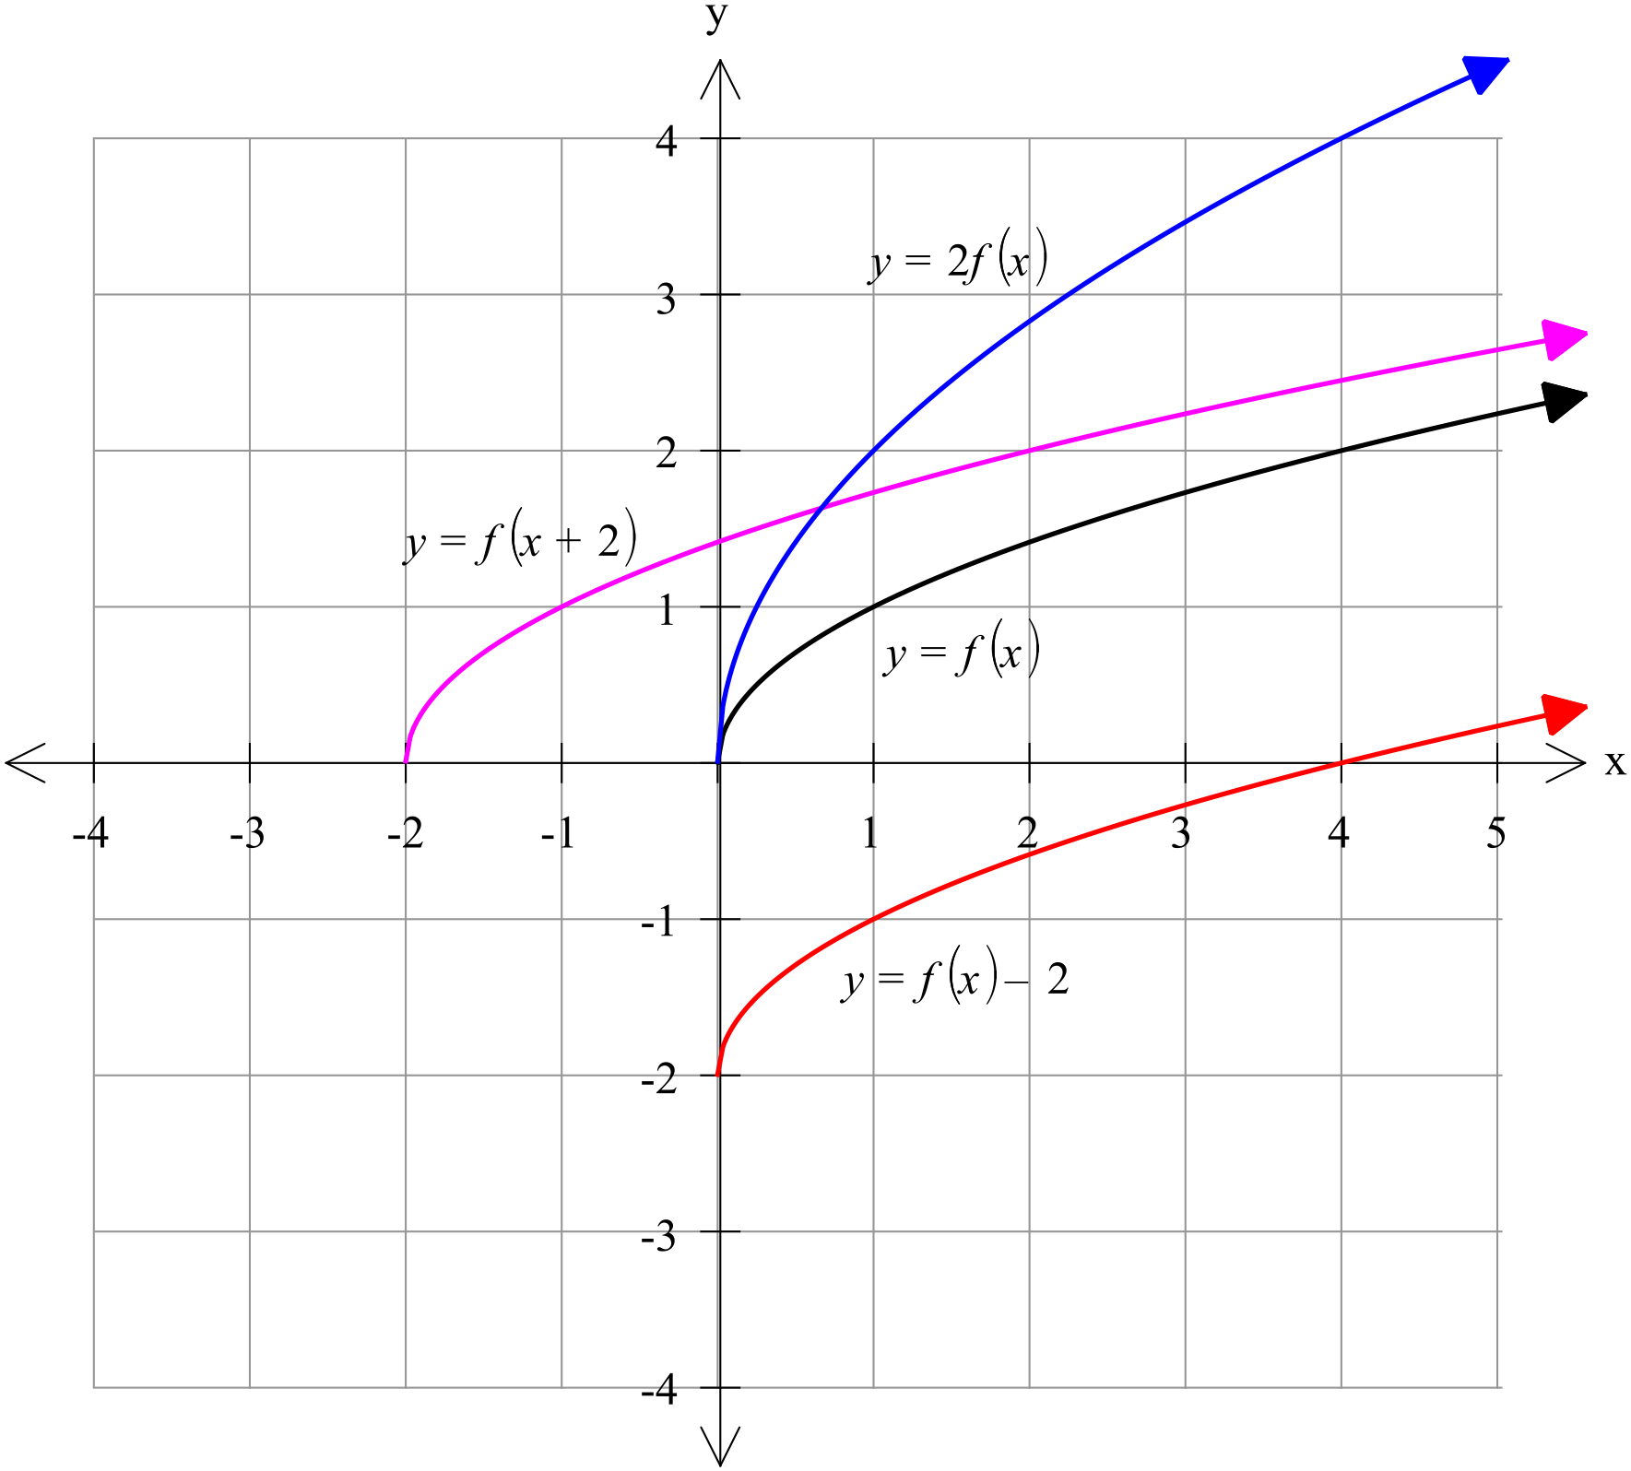

### [12 marks]

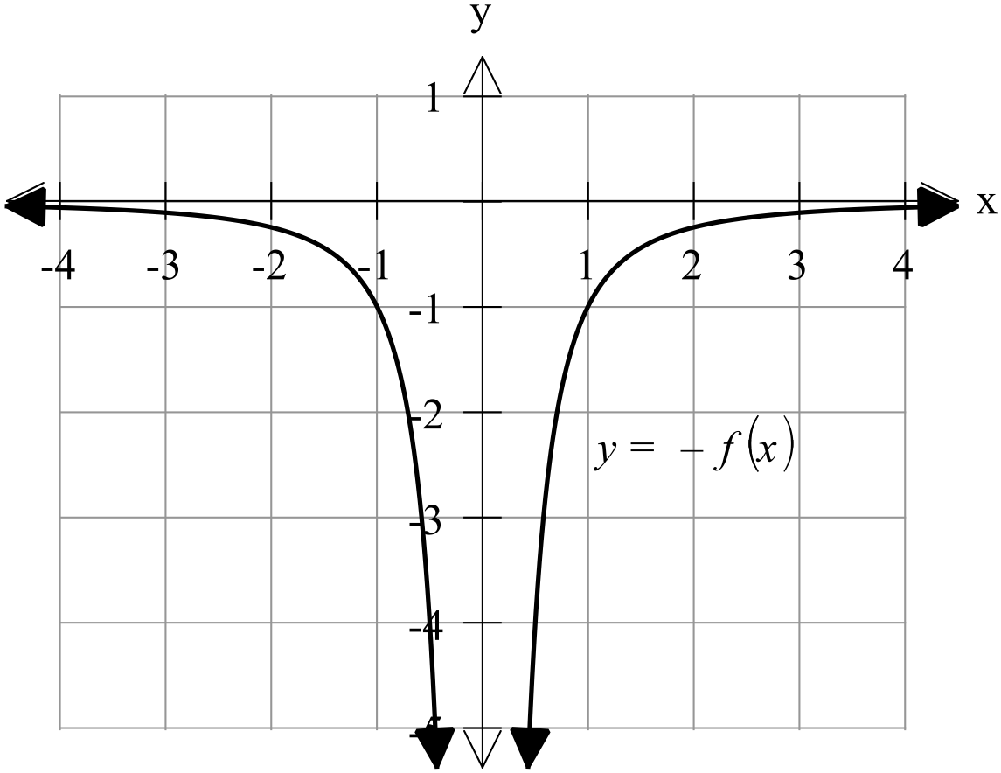 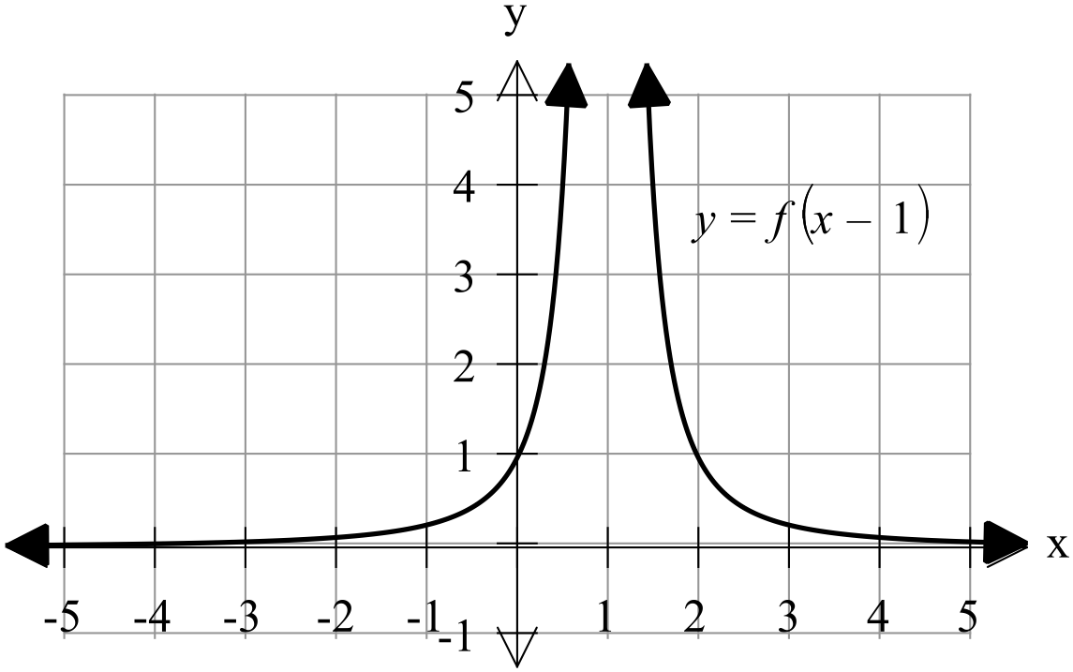

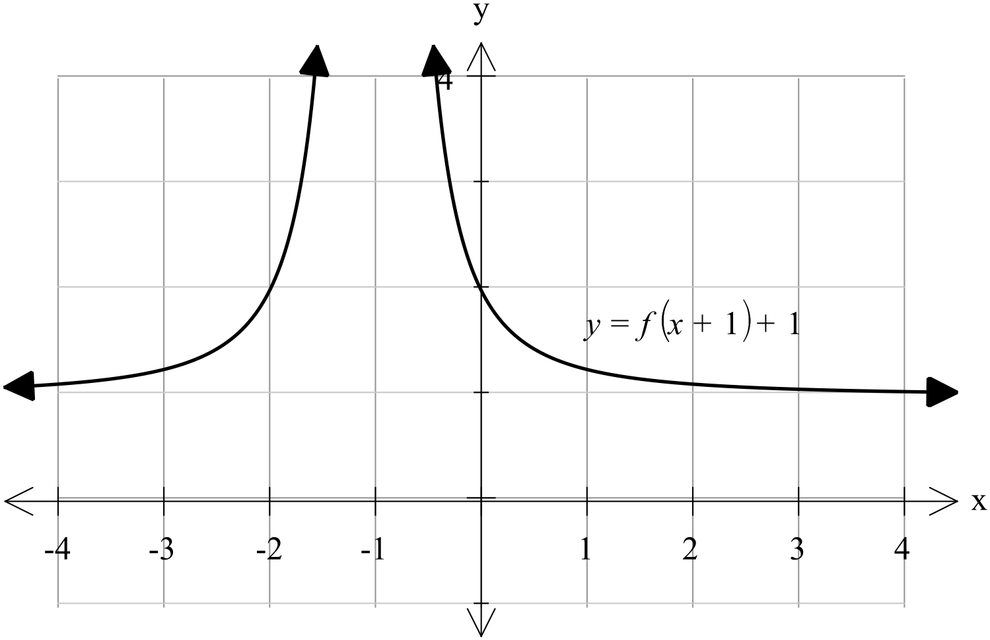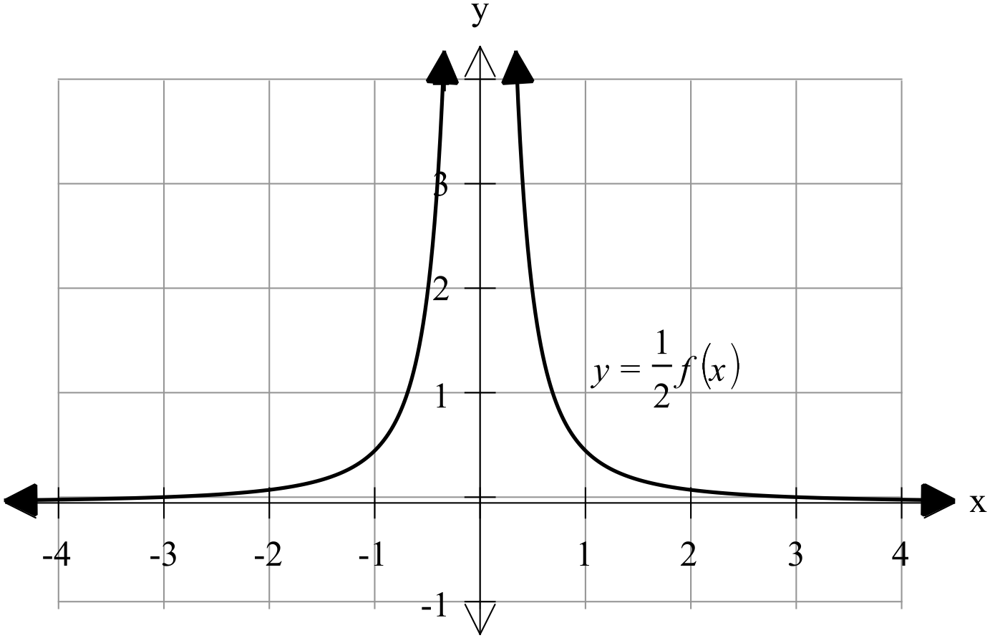

### [2 marks]

Graph 2:

### [2 marks]

Graph 4:

### [4 marks]

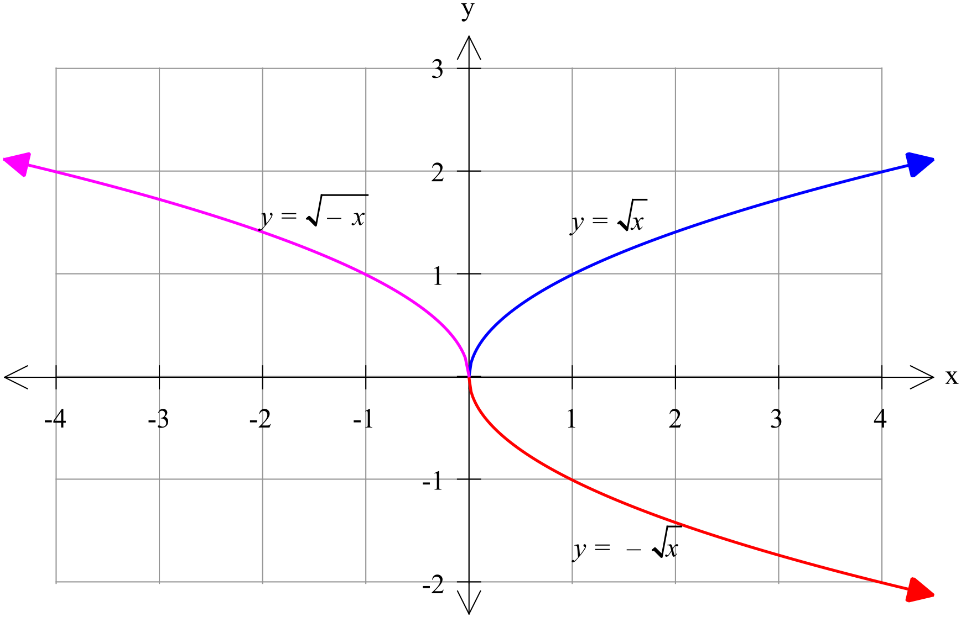

### [3 marks]

Both and are congruent to but is a vertical reflection (a reflection about the x axis) while is a horizontal reflection (a reflection about the y axis).

7. [4 marks]

b = 4

6 = a (3) + 4

a =

( 3c )+4 where x = 1

( 3c )

3c = 1

Therefore c = 0